EXPERIMENT – 2
NAME: NIVETHA R
ROLL NO: 240701373
Setting up a Zoho Creator Account and Exploring the Platform Architecture and Interface
AIM:
To set up a Zoho Creator account, create a sample application, explore the creation of forms, reports and dashboards, and understand the Develop, Deploy and Manage sections of the Zoho Creator platform.

SETTING UP ZOHO CREATOR:
Step 1: Creating a Zoho Creator Account
- Open a web browser and visit the Zoho Creator website.
- Click on Sign Up or Get Started.
- Create a Zoho account using a valid email address.
- Log in to the Zoho Creator platform.
- After successful login, the Zoho Creator home page is displayed.
- From the home page, a new application can be created.

Step 2: Creating a Sample Application
- Log in to Zoho Creator.
- Select Create Application.
- Choose the option to create an application from scratch.
- Enter the application name as Corporate Asset Maintenance.
- Click Create.
- The application builder opens, where different components such as forms, reports and pages can be created.
EXPLANATION:
The Corporate Asset Maintenance application is designed to maintain and manage information about assets owned or used by an organization. It can be used to record asset details, monitor asset status, track maintenance information and provide summarized information through reports and dashboards.
SCREENSHOT:
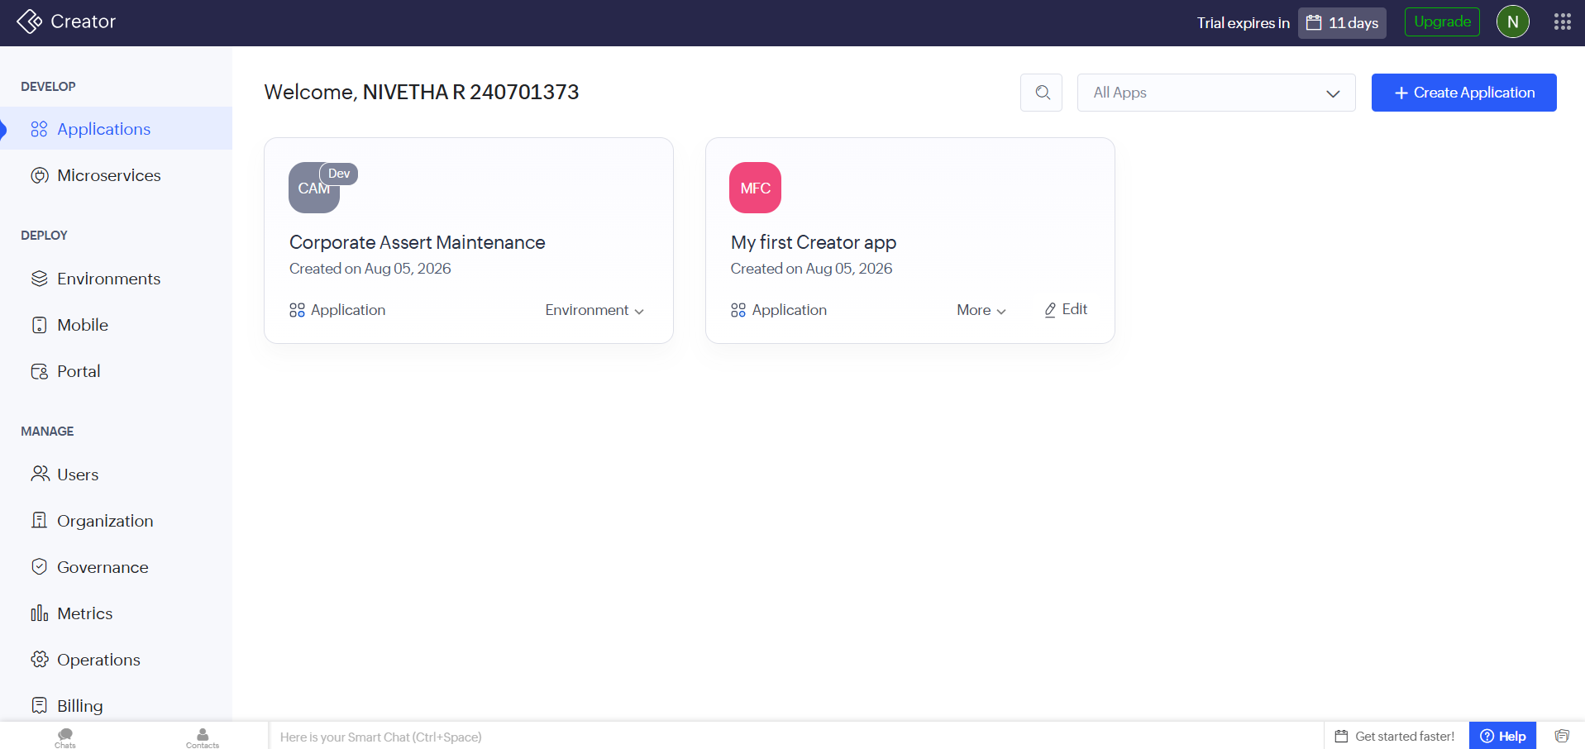
Figure 1: Corporate Asset Maintenance Sample Application

Step 3: Creating the Asset Details Form
- Open the Corporate Asset Maintenance application.
- Go to the Develop/Build section.
- Select Form.
- Create a new form.
- Name the form Asset Details.
- Add the following fields:
  - Asset ID
  - Asset Name
  - Asset Category
  - Asset Serial Number
  - Purchase Date
  - Warranty Expiry Date
  - Purchase Cost
  - Asset Status
- Save the form.

EXPLANATION:
A form is used to collect and store asset information in the application. The Asset Details form records important information such as asset ID, asset category, serial number, purchase date, warranty details, purchase cost and asset status. This helps the organization maintain an accurate record of its assets.
SCREENSHOT:
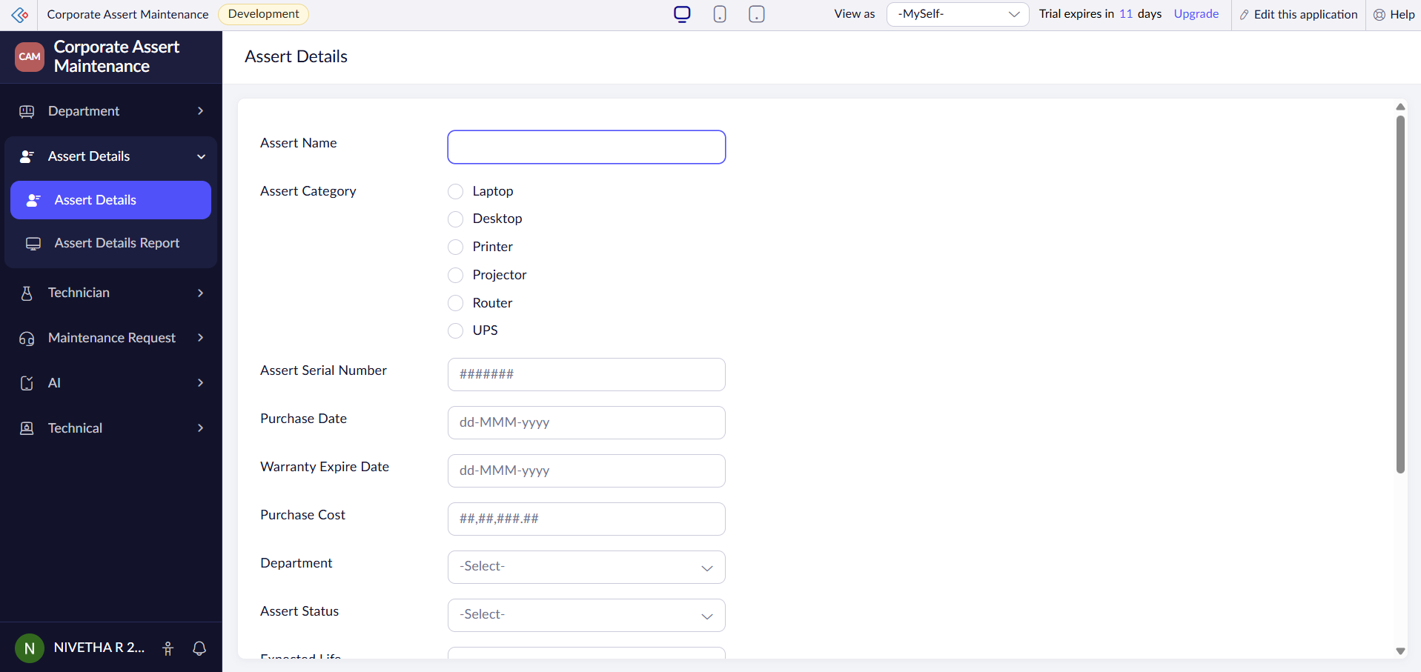Figure 2: Asset Details Form

Step 4: Creating the Dept Report
- Open the Corporate Asset Maintenance application.
- Go to the Develop/Build section.
- Select Report.
- Create a new report using the Department form as the data source.
- Select a suitable report format such as a table/list report.
- Name the report Dept Report.
- Save the report.
- Add a few sample asset records using the Department form.
- Open the report to view the stored asset records.

EXPLANATION:
A report is used to display and organize the adept records stored in the application.
SCREENSHOT: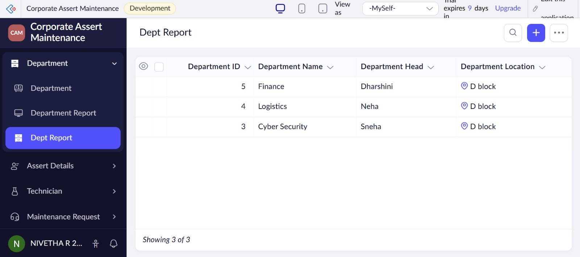
Figure 3: Dept Report

Step 5: Creating the Asset Maintenance Dashboard
- Open the Corporate Asset Maintenance application.
- Go to the Develop/Build section.
- Create a new page or dashboard.
- Name it Asset Maintenance Dashboard.
- Add suitable components such as reports, charts and summary information.
- Create charts using the Department data.
- Save the dashboard.
EXPLANATION:
A dashboard provides a visual and summarized representation of asset-related information. The Asset Maintenance Dashboard can display the Dept Report, Total visitors and Donut chart. It helps management monitor assets and make maintenance-related decisions efficiently.

SCREENSHOT:
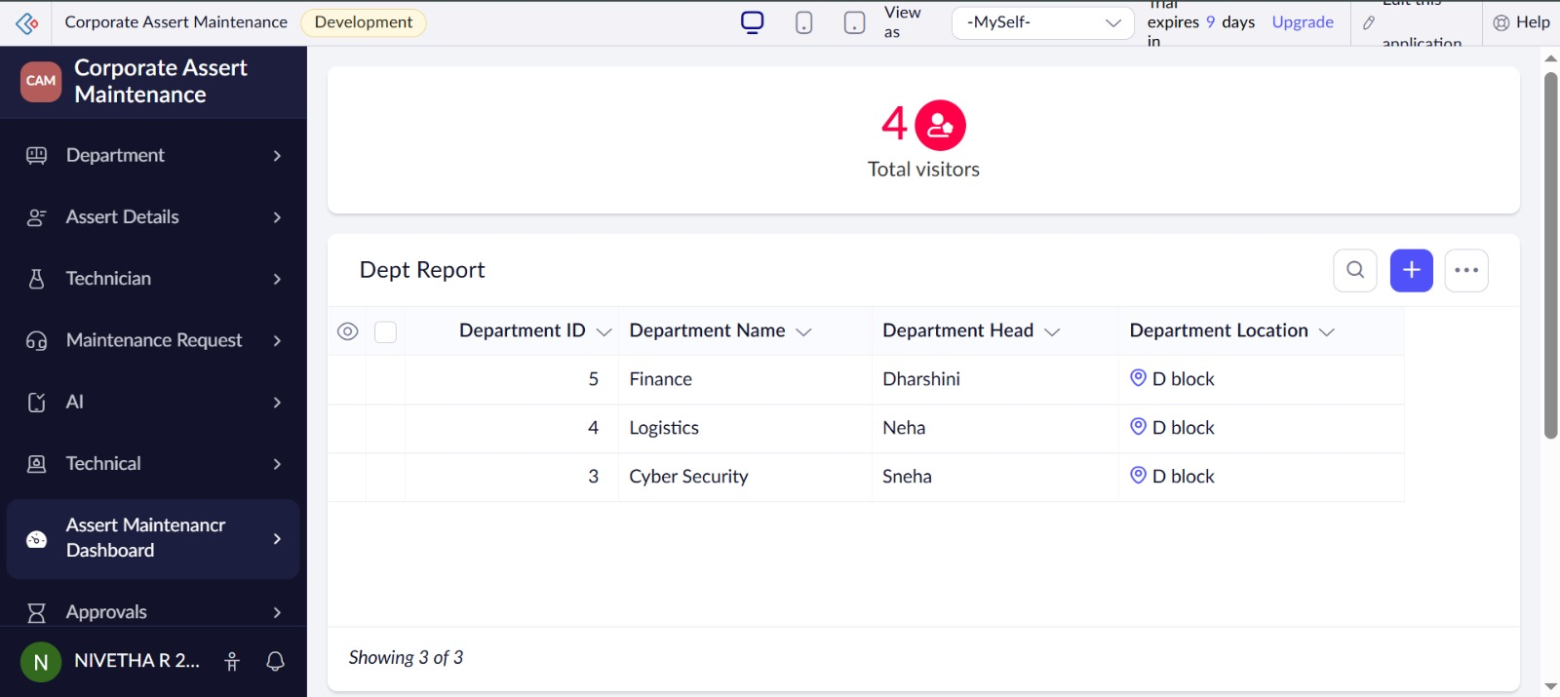
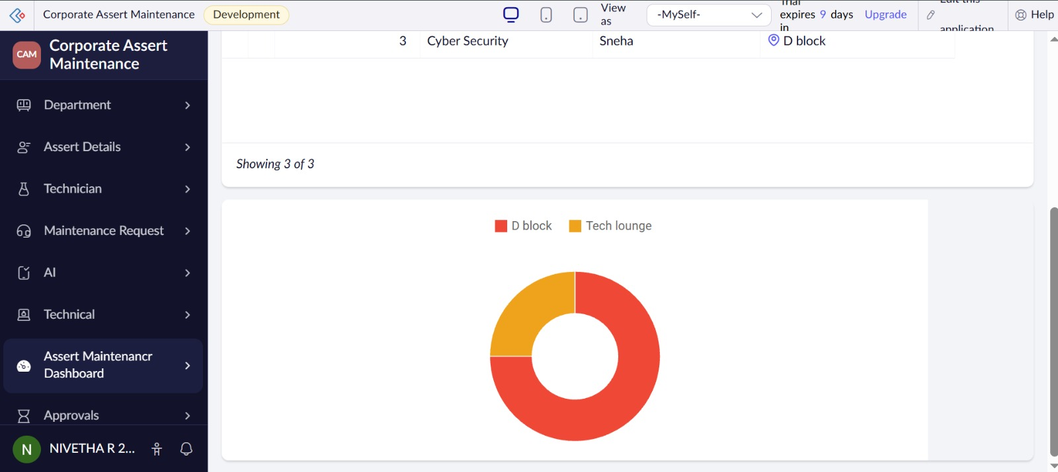Figure 4: Asset Maintenance Dashboard

EXPLORING THE PLATFORM ARCHITECTURE AND INTERFACE:
A) DEVELOP
- The Develop section is used to create and customize the Corporate Asset Maintenance application.
- It allows users to create forms, reports, pages, workflows and other application components.
- It provides visual development tools and configuration features for implementing asset management functionality.

B) DEPLOY
- The Deploy section is used to make the Corporate Asset Maintenance application available to authorized users.
- It allows the application to be tested, published and accessed according to the required permissions.
- Deployment enables employees and administrators to use the asset maintenance application.
C) MANAGE
- The Manage section is used to administer and maintain the Corporate Asset Maintenance application.
- It provides options for managing users, permissions, application settings and administrative functions.
- It helps administrators monitor the application and control access to corporate asset information.

RESULT:
Thus, a Zoho Creator account was successfully created and a Corporate Asset Maintenance sample application was developed. The Asset Details form, Asset Details Report and Asset Maintenance Dashboard were created successfully. The Develop, Deploy and Manage sections of the Zoho Creator platform were also explored.

